Lambda function using SAM (Serverless Application Model) to AWS Lambda Deployment Package in Python

Issue: While testing lambda functions on AWS Console leads to a limitation when external dependencies need to be added to the project. In my case Scipy.py, the best solution I found was use SAM, to locally test my function and add external packages.

Keys: CloudFormation, SAM

Other solution create a virtualenv



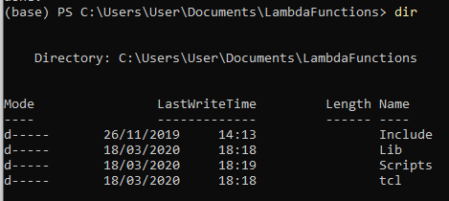

Activate the virtual environment



Then install Scipy

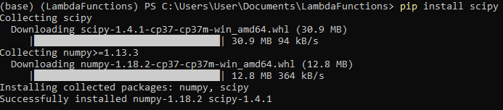

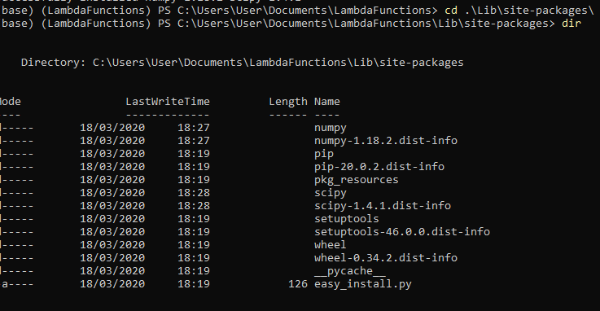

Copy lambda_function.py from AWS Console and save in Lib/site-packages

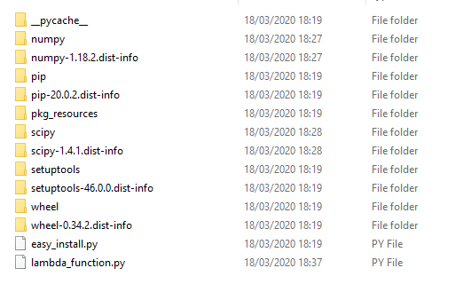

Zip all dependencies open Lambda AWS and drag the zipped folder

AWS Lambda Layers

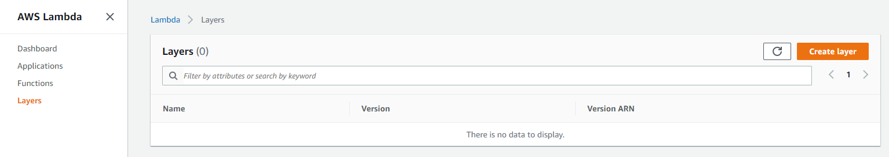

Create a Layer

Create S3 bucket and upload a zip folder with the dependencies need for the project

A easy way is run pip install scipy -t . then zip the folder and upload to S3

<https://itnext.io/creating-aws-lambda-applications-with-sam-dd13258c16dd>

<https://sanderknape.com/2018/02/comparing-aws-sam-with-serverless-framework/>

<https://medium.com/@adhorn/getting-started-with-aws-lambda-layers-for-python-6e10b1f9a5d>

<https://docs.aws.amazon.com/lambda/latest/dg/configuration-layers.html>

<https://www.youtube.com/watch?v=3BH79Uciw5w&list=PLqEbL1vopgvtQI4_y-t1To377jDojYcn0&index=3>

<https://github.com/mthenw/awesome-layers>

Possible Solution

<https://www.youtube.com/watch?v=ItE6MAZaiJY>

<https://docs.aws.amazon.com/lambda/latest/dg/python-package.html#python-package-dependencies>

<https://docs.aws.amazon.com/lambda/latest/dg/python-logging.html>